**2024-2025 SOUTHERN SOUND SERIES**

**SAILING INSTRUCTIONS – Amended 1 29 25 Section 20 (per Senate Bill 5371)**

**1. RULES**

This series of races will be governed by The Racing Rules of Sailing (2021-2024 for Winter Vashon) then (2025-2028) thereafter, the USSA Prescriptions, class rules (including PHRF NW class rules), these Southern Sound Series Sailing Instructions and Notice of Race. Any individual non-race specific information will be published by the respective race’s sponsoring club on their website and may include information on moorage availability, pre & post-race events and meals, tee shirts, etc.

If there is a conflict between the Series Sailing Instructions and the Series Notice of Race, the

Series Sailing Instructions shall prevail. This changes RRS 63.7

Non-PHRF Cruising and Commodore Class boats are subject to Non-PHRF Classes Rules; see Appendix A below.

All competitors must follow the USCG VTS Navigation Rules and COLREGs.

**2. CHANGES IN SAILING INSTRUCTIONS**

Sailing Instructions may change between races. Changes to the Sailing Instructions will be posted on the series website: ssseries.org no later than 1 week prior to race day.

**3. SIGNALS MADE ASHORE OR RACE COMMITTEE VESSEL**

Location of signals made ashore or race committee vessel are defined in the Individual Race Sailing Instructions below.

When the AP is displayed ashore or race committee vessel, ‘1 minute’ is replaced with ‘not more than 60 minutes’ in the Race Signal AP Rule. Regardless of the location of the AP, the starting will commence between 1 minute and 60 minutes of the lowering of the AP Flag.

**4. SCHEDULE OF RACES**

There will be one distance race on each race day.

Race Committee Time will be Universal Pacific Standard/GPS time.

For all races:

PHRF and non-PHRF Cruising NFS and Commodore FS Class warning 0925

First PHRF Racing Class (highest numbered PHRF class) warning: 0955

Additional PHRF Racing Classes from highest to lowest PHRF class shall start five minutes after the prior respective PHRF Class

One Design Classes following five minutes after the last PHRF class start

ORC Class start following five minutes after the One Design Classes, or if no One Design Classes, five

minutes after the last PHRF class start

**5. CLASS FLAGS**

Class flags for each class will be the letter flag or numerical pennant flag for the class.

PHRF and non-PHRF Cruising NFS and Commodore FS Classes "C" Flag

PHRF Classes respective number pennant

Class1 – multi hulls "1" pennant

ORC Class "0 (zero)" pennant

One Design class designed flag or agreed upon letter flag

**6. CLASSES**

The Class breaks for this year’s Series were determined Friday evening before the Winter Vashon Race. Updated class breaks are posted to Southern Sound Series website: ssseries.org and provided below. The RC may assign boats to a class based on the boat's design, when in their opinion it would make for fairer racing.

**PHRF Classes**

Class 1: Multi Hulls class

Class 2 PHRF class numerically to as many classes as may be determined prior to the Winter Vashon Race as listed below

PHRF3 – 0 to 66

PHRF4 – 67 to 86

PHRF5 – 87 to 119

PHRF6 – 120 to 144

PHRF7 – 145 and up

PHRF9CruisingNFS

PHRF10CommodoreFS

**Non-PHRF Cruising Classes**

NonPHRFCruisingNFS

NonPHRFCommodoreFS

**ORC Class**

All boats with active 2024 ORC certificates for the Winter Vashon, Duwamish Head, and Toliva Shoal races and 2025 ORC certificates for the Islands Race.

**Handicap Changes**

In the event of a handicap change during the Series which would result in the boat’s assignment to a different class:

- If the skipper does nothing the boat will remain in the class to which she was originally assigned. Her scores in already sailed races stand.

- If her skipper wishes to transfer to the new class, the skipper must obtain approval from the Race Chair for the next race in the series prior to the registration deadline for that race. The boat’s scores in already sailed races will still be counted in the old class and not transferred to her new class.

**7. COURSES**

Courses are approximately defined as follows:

**Winter Vashon.** Race Starting and ending near the Tacoma Yacht Club racing clockwise around Vashon Island. Approximate distance 30.7 nm.

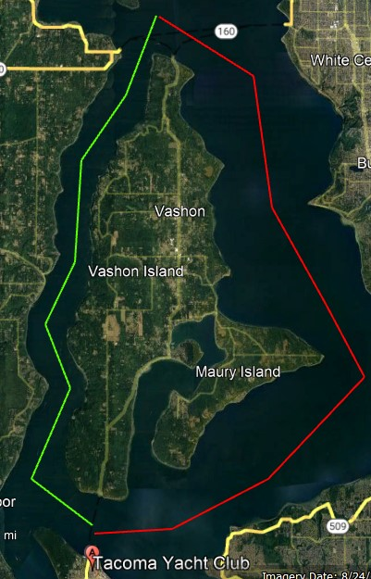

PHRF, ORC, PHRF and Non-Flying Sails Cruising and Commodore, and One Design Classes all start from the RC boat anchored near TYC Clubhouse in a westerly direction racing **CLOCKWISE** around Vashon Island crossing the finish line off the TYC clubhouse in a westerly direction.

An orange or yellow inflatable mark will be anchored as a limiting mark approximately ½ mile North of the ferry dock at the North end of Vashon Island (on Allen Shoal). This mark shall be left to **STARBOARD**. A North End Race Committee boat may be anchored approximately 200 yards north of the limiting mark. If the North End Committee boat is on station, all boats must pass between the committee boat and the limiting mark.

If conditions prevent anchoring an orange or yellow inflatable mark, it may be placed on the bow of the North End RC boat, in which case the entire boat should be treated as the limiting mark. This mark shall be left to **STARBOARD**. (Please be mindful that the **North End RC boat is provided by a volunteer and effort should be made to avoid colliding with the North End RC boat**.)

SHORTENED COURSE The race committee shall announce a shortening of the race on channel 72 and display the shortened course flag. The course may be shortened for fleets sailing around Vashon Island at the limiting mark at the North end of Vashon Island. Sub sections a, b, and c of RRS 32.2 are replaced with: …the finishing line shall be between a staff on the North End RC boat displaying the flag S and an Orange or Yellow Mark set to the south of the RC boat. Or, if the RC was unable to set a mark the line between the RC and the southern tip of Blake Island. This changes RRS 32.2

FERRY BOAT CLEARANCE: at the north and south ends of Vashon Island the race course crosses ferry lanes. All boats must maintain a minimum 500 yard distance from any FERRY BOAT regardless of its location and speed which has the right of way at all times. All boats shall stay clear of the Point Defiance ferry landing area before, during, and after the race.

TRAFFIC SEPARATION LANES: **Race participants shall monitor VHF Channel 14 in addition to VHF Channel 72**. As some of the race will be in or in the vicinity of the Traffic Separation Scheme, all skippers and crews are expected to be fully familiar with and comply with Rule 10 of the International Regulations for Preventing Collisions at Sea which states: Skippers are reminded that vessels under sail DO NOT always have the right of way over power driven vessels. “…a sailing vessel shall not impede the safe passage of a power-driven vessel following a traffic lane.” Race participants are expected to yield to vessels in the traffic lane even to the detriment of competitive position. If a race participant needs to contact Vessel Traffic Service (VTS) they should use VHF Channel 14. Interference with ferry or traffic lane power driven vessels may result in a boat being disqualified.

Tacoma Yacht Club offers limited guest moorage for race participants prior to and following the race. Please provide your request for moorage when registering for the Winter Vashon Race on the regatta network registration form. When moored, please register at the dock and if electrical connection is used pay the $2.00/ night connection fee at the dock registration box.

Information on pre and post-race activities will be posted on the Tacoma Yacht Club web site https//www.tacomayachtclub.org.

**Duwamish Head**. Race starting and ending at Des Moines Marina going around Duwamish Head and Blakely Rock, leaving both to port. Approximate distance 30.8 nm.

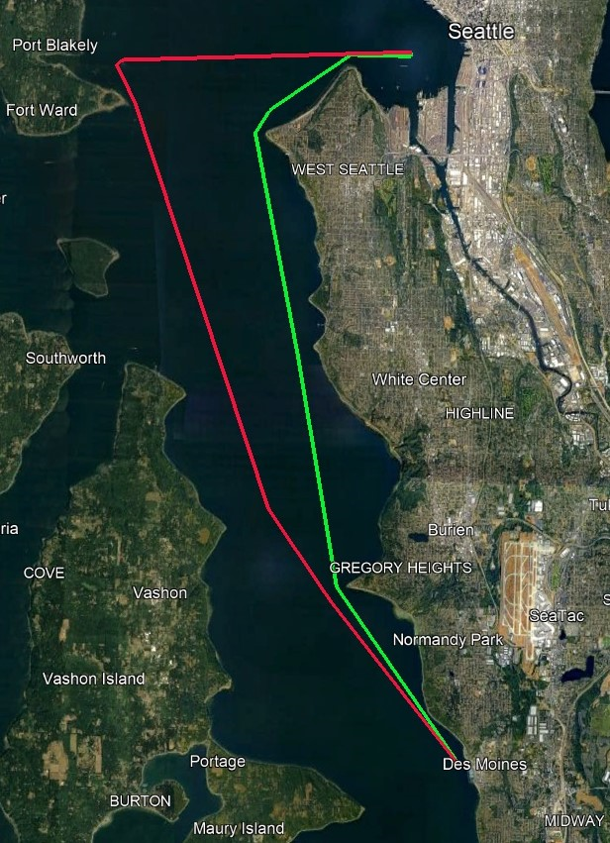

All classes start in a northerly direction between a RC Flag on the end of the Des Moines fishing pier and an offshore orange mark, leaving the mark to **PORT**. Proceed north to the Duwamish Head Light, leaving it to **PORT** and then proceed west to Blakely Rock Light, leaving it to **PORT**. Then proceed south to the finish line.

The green lighted navigation buoy to the south of the Des Moines Fishing pier is a limiting mark. Boats will not sail between it and the pier while starting or finishing. Boats will note the name/sail number of the boat finishing in front and behind them.

If the finish mark should not be on station, boats will finish by crossing a line between the RC flag at the end of the fishing pier to the Point Robinson lighthouse.  Finishers should pass within approximately 10 boat lengths from the end of the fishing pier. The Race Committee will broadcast this modification to the finish line on VHF 72.  This modifies RRS 34.

Boats finishing in darkness or reduced visibility will illuminate their sail numbers with a light.

SHORTENED COURSE: The race committee shall announce a shortening of the race on channel 72 and display the shortened course flag. Dependent on weather conditions, the course may be shortened to finish on a line between the western edge of the Duwamish Head Light and a RC flag and letter S flag displayed on a committee boat near the Duwamish Head Light dolphin. This changes RRS 32.2. 7.2. Race distance of the shortened course is 13.5 nm. Alternatively, the course may be shortened as above, but on a finish line between the north side of Blakeley Rock and the RC committee boat anchored to the north of Blakeley Rock approximately 18.8 nm.

FERRY BOAT CLEARANCE: Ferries travel between the north end of Vashon Island and Fauntleroy, Seattle and Bremerton, and Seattle and Bainbridge Island. All yachts must maintain a minimum 500 – yard distance from any ferry boat, regardless of its location and speed, which has the right of way at all times.

TRAFFIC SEPARATION LANES: **Race participants shall monitor VHF Channel 14 in addition to VHF Channel 72**.As some of the race will be in or in the vicinity of the Traffic Separation Scheme, all skippers and crews are expected to be fully familiar with and comply with Rule 10 of the International Regulations for Preventing Collisions at Sea which states: Skippers are reminded that vessels under sail DO NOT always have the right of way over power driven vessels. “…a sailing vessel shall not impede the safe passage of a power-driven vessel following a traffic lane.” Race participants are expected to yield to vessels in the traffic lane even to the detriment of competitive position. If a race participant needs to contact Vessel Traffic Service (VTS) they should use VHF Channel 14. Interference with ferry or traffic lane power driven vessels may result in a boat being disqualified.

Three Tree Point Yacht Club may offer limited race participant moorage on Friday prior to the race check the Three Tree Point Yacht Club website for more information at https://www.ttpyc.org.

North transiting boats from areas south of Tacoma seeking TYC transient moorage: Tacoma Yacht Club has limited reciprocal mooring available on a first come first serve basis. Approximately 100 feet of dock space within the “V” at the western end of the guest moorage area and limited to a maximum of four boats. Rafting is possible. Sorry no reservations. If planning on utilizing TYC reciprocal dock space please notify the SSSS race chair no later than mid-September. An attempt to provide additional moorage will be made with the earlier moorage request notices. Registration is required at the dock or clubhouse. Please, also fly your burgee. There is a $2.00/night charge for power. For stays more than 48 hours a $1.00/foot/day (minimum $20.00) fee is charged. Additional transient moorage is available on a first come first serve basis at the Point Defiance Public Dock

Information on pre and post-race activities will be posted on the Three Tree Point Yacht Club web site https://www.ttpyc.org

**Toliva Shoal**.Start between the Race Committee Boat and the east marker of the Olympia Shoal in a northerly direction. Proceed leaving Dofflemyer Point and Johnson Point to **STARBOARD**; then the government mark #3 off Nisqually Delta, the Toliva Shoal buoy, Eagle Island, the government mark #1 at the west end of Balch Passage, Johnson Point, and Dofflemyer Point to **PORT**. Finish in a southerly direction between the race committee boat and the east marker of the Olympia Shoal. Approximate distance 38.4 nm

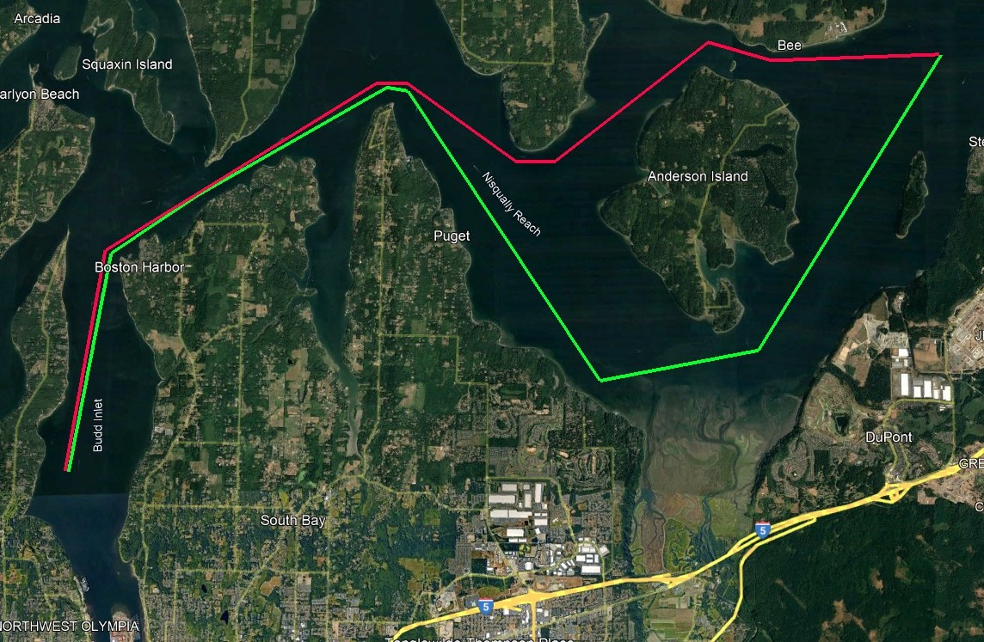

SHORTENED COURSE: The race committee shall announce a shortening of the race on channel 72 and display the shortened course flag. The course may be shortened for fleets sailing at any of the following points Dofflemyer Point or Johnson Point (departing or returning), the government mark #3 off Nisqually Delta, the Toliva Shoal buoy, the government mark #1 at the west end of Balch Passage.

Transient moorage is available at the Swantown Marina guest dock, Olympia Yacht Club reciprocal dock, and Percival Landing

Information on pre and post-race activities will be posted on the Olympia Yacht Club and South Sound Sailing Society web sites: <https://www.ssssclub.com> & <https://www.theolympiayachtclub.com>

**Islands Race.** Starting area will be the vicinity immediately west of the Browns Point Light House. The starting line is established between the CYCT RC signal boat flying an orange flag and a temporary orange tetrahedron pin. After the start proceed north to Three Tree Point leaving the traffic separation mark VTS “TB” west of Des Moines to **PORT**. Round the TTPYC “C” mark, a permanent white 6” cylinder rising 8 feet above the water located approximately 1,000 feet SE of the Three Tree Point Light, to **PORT**. Proceed northwesterly to the turn mark located to the north of Blake Island and round to **PORT**. Return southeasterly leaving the traffic separation marks VTS “TA” and “TB” off Three Tree Point and Des Moines respectively to **PORT**. Finish west of Browns Point between the CYCT RC boat and the temporary orange tetrahedron pin. Approximate distance 35.2 nm.

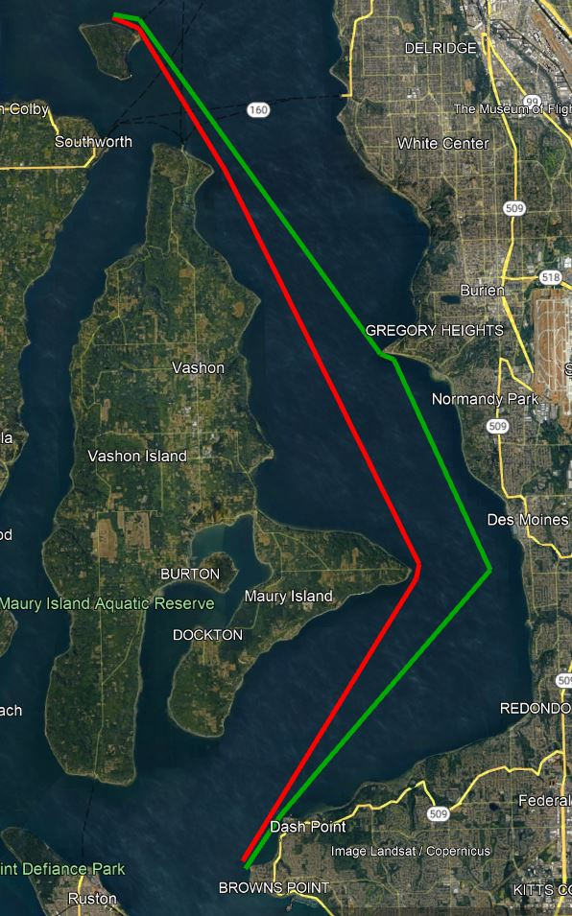

SHORTENED COURSE: The race committee may shorten the course as follows: between the TTPYC “C” mark, the Blake Island turning mark, or the traffic separation marks VTS “TB” east of Point Robinson and the race committee boat. The race committee shall announce a shortening of the race on channel 72 and display the shortened course flag.

FERRY BOAT CLEARANCE: Ferries travel between the north end of Vashon Island and Fauntleroy, Seattle and Bremerton, and Seattle and Bainbridge Island. All yachts must maintain a minimum 500 – yard distance from any ferry boat, regardless of its location and speed, which has the right of way at all times. Interference with ferry traffic may result in a boat being disqualified.

TRAFFIC SEPARATION LANES: **Race participants shall monitor VHF Channel 14 in addition to VHF Channel 72**. As some of the race will be in or in the vicinity of the Traffic Separation Scheme, all skippers and crews are expected to be fully familiar with and comply with Rule 10 of the International Regulations for Preventing Collisions at Sea which states: Skippers are reminded that vessels under sail DO NOT always have the right of way over power driven vessels. “…a sailing vessel shall not impede the safe passage of a power-driven vessel following a traffic lane.” Race participants are expected to yield to vessels in the traffic lane even to the detriment of competitive position. If a race participant needs to contact Vessel Traffic Service (VTS) they should use VHF Channel 14. Interference with ferry or traffic lane power driven vessels may result in a boat being disqualified.

Information on pre and post-race activities will be posted on the Corinthian Yacht Club Tacoma web site <https://www.cyct.com>

Transient Moorage is available at [Foss Marina](https://www.fossharbormarina.com/Default.aspx), Foss Waterway Seaport, and Tacoma Yacht Club Reciprocal if space is available. Advance reservations can be made at Foss Marina and Foss Waterway Seaport.

**8. START**

Races will be started in accordance with Racing Rule 26 with class starting sequence in the following order: PHRF and non-PHRF Cruising NFS and Commodore classes, followed by the PHRF classes in reverse starts (highest PHRF # first), followed by any One Design Class/es, then followed by the ORC class. Vessels shall assume each class will start separately. Race start sequences and classes will attempt to be announced over VHF 72.

The starts will be indicated class flags and shall rule over starts announced or attempted to be announced over VHF 72.

The PHRF and non-PHRF Cruising NFS and Commodore classes and first PHRF start warning shall be announce or attempted to be announced over VHF 72 followed immediately by announcing the next class to be started.

TIME LIMIT

Time limit for all races is 13 hours after each class start.

No boat shall finish after the time limit. Finishing after the time limit will be scored DNF.

**9. SCORING**

**9.1** PHRF time corrections will be calculated using Time-On-Distance.

**9.2** If 4 races are completed, a boat’s worse score will be excluded. This changes Rule A2.

**9.3** All handicaps will be checked with the handicapping authority. Any boat whose handicap cannot be verified within 14 days after each race will not be scored.

**9.4** Boats scored DNF, RET, OCS, or DSQ will be scored the number of boats that finished the race plus 1. This changes Rule A4.2.

**9.5** Boats scored DNC or DNS will be scored the number of boats that finished the race plus 2. This changes Rule A4.2.

**9.6** Race results will be posted on the Regatta Network.

**9.7** Scoring for the ORC class will be All Purpose Handicap Time on Distance (APHTod). Please note from the Offshore Racing Congress, ORC Race Management Guide 2024 USA_CAN edition:

*“The decision on the scoring method and scoring parameters used for a race will be at the sole discretion of the Race Committee. This includes the length of the course, directions of the legs and the wind details such as strength and direction. These will not be grounds for a request for redress by the boat. This changes RRS 60.1(b).”*

Series Ties

A tie shall be broken in favor of the boat with the best excluded score (throw-out). If a tie remains, then Rule A8.1 and Rule A8.2 will be applied.

**10. SHORTENED COURSE OPTION:**

Individual race sponsors may elect to use a shortened course options as identified in these Sailing Instructions.

**11. CHECK-IN AND RETIRING**

Boats must check in with the race committee signal boat on CH 72 at the starting area prior to their first warning signal. A boat that retires while racing must orally notify the race committee on CH 72 as soon as possible after retiring by hailing, or using the VHF or telephone number provided on the race sponsor’s website for their respective RC. If no response is received back from the race committee, the retiring boat shall repeat their notification to the race committee. If no response is again received other boats should forward on the retiring boats message to the race committee. In the past, failing to inform the race committee of a boat’s retirement has led to race committee and/or chase boat searches and have at times led to Coast Guard searches.

**12. PENALTY SYSEM**

The ‘Two Turn Penalty’ is replaced with a ‘One Turn Penalty’ thus modifying Rules 44.1 and 44.2. Rule

44.3 shall not apply.

**13. RACE SIGNALS**

Signal flag ‘N’ and/or signal flag ‘N’ over a class flag means abandonment. Since there is only a single race possible per day, any abandonment will be the end of racing for the day for the effected classes.

**14. PROTESTS**

Protests MUST be emailed AND ACKNOWLEDGED within 48 hours of the boat’s full course time limit.

An email address for each race is posted in the Notice of Race.

The Protest Committee will make every effort to hear protests the Thursday following the event and boats should be prepared for a hearing at that time.

Series request for Redress. In the event a request for redress is lodged pertaining to the Series, as opposed to an individual race, a redress committee consisting of one member each from TYC, TTPYC, SSS/OYC, and GHYC will be appointed to hear the request. The time limit for receipt of a series request for redress is two weeks from the date of the last series race. Series protests may be mailed to:

**Southern Sound Series Protest Committee, PO Box 1102, Olympia, WA 98507**

In addition to following the rules of Part 5, a boat intending to protest or request redress as a result of an incident on the race course shall inform the Race Committee of her intent using VHF, Hail, or telephone within 10 minutes of her finish.

**15. SAFETY REGULATIONS**

**15.1** Safety requirements US Sailing Nearshore, except that any single or double-handed crews must wear a PFD at all times.

**15.2** Be aware that at times you may be sailing in the Vessel Traffic Lanes. Watch out for commercial traffic! Racers are required to monitor Seattle Traffic is on VHF Channel 14. You must monitor this channel in addition to channel 72. If a boat fails to respond to a hail from a vessel or Vessel Traffic Services (VTS), the Race Committee may score the boat DSQ without a hearing. This changes RRS A5.1.

**15.3** The race committee reserves the right to cancel or delay racing due to unsafe conditions. However, the fact that the race committee has not canceled a race, nor the fact that other boats are still racing, should not be interpreted to mean that conditions are necessarily safe for all vessels. It is the responsibility of the individual yacht to decide when conditions are unsafe for their vessel and to take appropriate safety measures.

**15.4** Separation from Ferry Traffic is required, vessels must not approach within 500 yards of a ferry. Interference with ferry traffic may result in a boat being disqualified.

**16. COMMNICATION WITH RACE COMMITTEE**

Race Committee will monitor **VHF Channel 72** during the race.

The Race Committee’s cell phone numbers are published in the Notice of Race and may be used during the race as an alternative to VHF channel 72.

**17. USE OF MOTORS**

**17.1** Motors shall not be used for propulsion while a boat is racing (as defined in the RRS) unless for one of the exceptions listed below. Allowable exceptions where motor use is allowed include:

17.1.1 When following RRS 1 (Helping Those in Danger).

17.1.2 To move out of the way

of commercial vessel traffic.

17.1.3 To move another boat or herself off of a grounding.

17.1.4 To gain steerage to prevent a boat from being pushed by the wind or currents

into an otherwise certain and immediate grounding

17.1.5 To get a boat to the starting area for the first time that morning or to prevent a boat from being pushed by the wind or the currents into the Race Committee boat at the start. In this case, the boat shall not start until four minutes after her motor has been turned off.

17.1.6 To charge batteries or for other electrical uses or heat, as long as the engine is not placed in gear.

**17.2** In no case should the use of the motor have reduced the distance a boat will need to sail to finish the course, nor should the use of the motor place the boat in a more favorable position relative to the prevailing wind or current conditions or her competitors.

**17.3** In the event of any use of the motor for propulsion while racing, the boat’s skipper shall report by radio to the race committee the fact that the motor was run while she was racing. The boat’s skipper shall also file a written report with the race committee promptly after they have finished the race (within the protest time limit). This report shall include the GPS coordinates and the time when the motor was started and when the motor was turned off with a full description of the circumstances and other relevant information (such as, but not limited to, water depth, boat speed and heading, current and wind conditions).

**17.4** If a report is not filed as described above, showing that fair racing was preserved as judged by the exclusive opinion of the race committee, the boat may be protested and disqualified.

**18. AIS Broadcasting**

If a participating vessel has the ability to broadcast AIS, per U.S. Coast Guard regulations, AIS must be broadcasting during all series races.

**19. Awards**

See the Notice of Race for the Series of Races

**20. State of Washington Senate Bill 5371 / Protecting Southern Resident Orcas from Vessels**

**20.1 Protecting Orcas**

Washington Senate Bill (SB) 5371 governs this event (see the definition Rule (g)). SB5371 states:

Operators of motorized vessels, non-motorized vessels and paddle crafts must stay 1,000 yards (approximately one-half nautical mile) away from southern resident killer whales (SRKW) in all directions. If the SRKW approaches within 400 yards of any vessel, state law requires that the vessel disengages the transmission, luffs sails, or stops paddling (if it is safe to do so) until the animal(s) moves away. Boaters who think they may be closer than 1,000 yards to SRKW, but not within 400 yards, should attempt to navigate out of the path and away from SRKW at a speed of 7 knots or less.

However, for this event the requirements of SB 5371 shall apply to all orca whales; not just SRKW. (c) Boats may be protested for breaking 20.

**20.2** If an orca is seen by the crew of a boat, the boat shall not enter the circular area within 1000 yards of the orca (therefore, that area is an obstruction.); and if the boat is within 400 yards of an orca, she shall, as soon as reasonably possible, luff (or, if motoring before or after racing, disengage her transmission) to slow to the slowest safest speed, which may be to stop, until they are no longer within 1000 yards of any orca.

**20.3** Add to RRS Rule 32.1

(e) if an individual orca or orca pod is found to be in, near, or approaching the race area.

**20.4** Add to RRS Rule 61.4 (b):

(6) reasonable actions she took to comply with NOR / SI X.

**APPENDIX A**

**Non-PHRF CLASS RULES**

Non-PHRF Cruising Class-NFS and a Commodore Class-FS will be offered at each race venue. No PHRF rating is required or will be used. Each vessel will be scored where it finishes in its class. These classes will be scored independently and will not be eligible for series overall or team awards.

Non-PHRF Commodore Class boats must comply with PHRF rules and regulations, except that membership in PHRF is not required. Boats may fly such sails as spinnakers, mizzen staysails, streakers, drifters flown from their own temporary stays, etc.

Non-PHRF Cruising Class-NFS boats must comply with PHRF rules and regulations for "No Flying Sails" rating, except that membership in PHRF is not required. This includes, but is not limited to, rules on whisker pole length and the rules listed below.

To be eligible for a "No Flying Sails" rating, boats must use working sails only: attached by their luff to permanent stays or spars. Not less than 90% of the luff length must be attached to the permanent stay or spar with not less than eight (8) snaps or sail track slides distributed evenly along the luff; or, alternately, attachment may be by a luff-rope groove. Only one (1) working sail luff may be attached to each permanent stay or spar.

Non-PHRF Cruising NFS and Commodore FS Classes: Only one sail may be used forward of the main mast on Sloops, Cutters, Yawls, and Ketches unless the yacht is specifically rated for carrying additional sails. When changing jibs, the "up" – hoisted – jib must be fully lowered to the deck before the replacement jib is raised. Before lowering the "up" jib, the replacement jib may be hanked on the forestay, or started in the second head foil groove up to five feet above the deck. The second halyard may be attached before lowering the "up" jib. Jibs may NOT be attached to temporary or detachable stays. NFS ratings exclude such sails as spinnakers, mizzen staysails, streakers, drifters flown from their own temporary stays, etc.

The above was excerpted from Pacific Handicap Racing Fleet of the Northwest PHRF-NW web site, No Flying Sails Rating.